HR AGENT – TEST OBSERVATIONS

1. Listing of Categories in the Left Pane
Left pane lists some categories like – Leave Balance, My Attendance, Payroll Info, Timesheet, My expenses, etc.
These categories are not required to be mentioned as segments, instead the HR agent should allow employees to ask any question as prompts and get the required response.
Currently this list looks like the Odoo page – which doesn’t differentiate an HR agent from the current Odoo page.
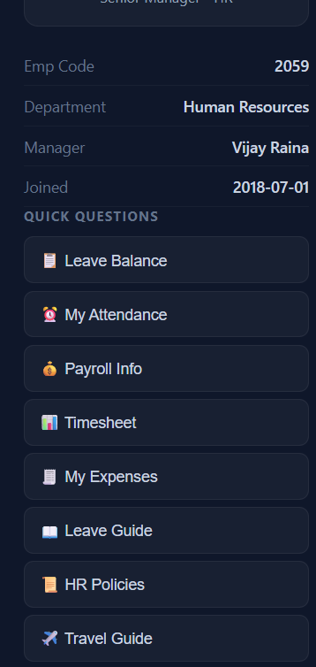

2. While clicking the categories mentioned in the left pane, the agent automatically assumes/ auto generates prompts and responds to the same.
Eg – Current: HR Policies Prompt is auto generated “List all HR policies available” Lists some policies
Proposed: Employee should be able to type prompts without auto generating prompts

3. When asked for current leave balance (CL only), the agent responds with the following data:
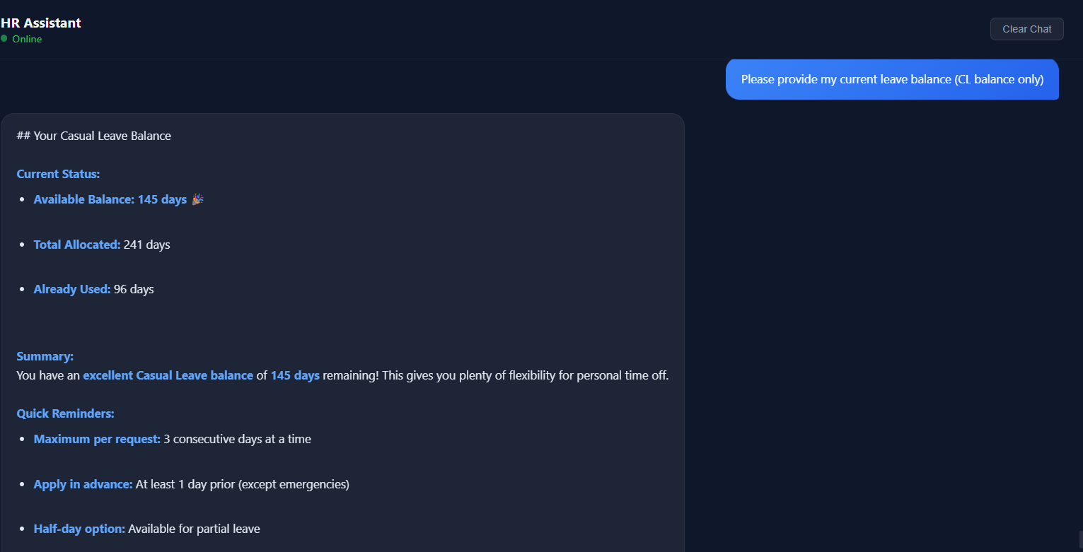
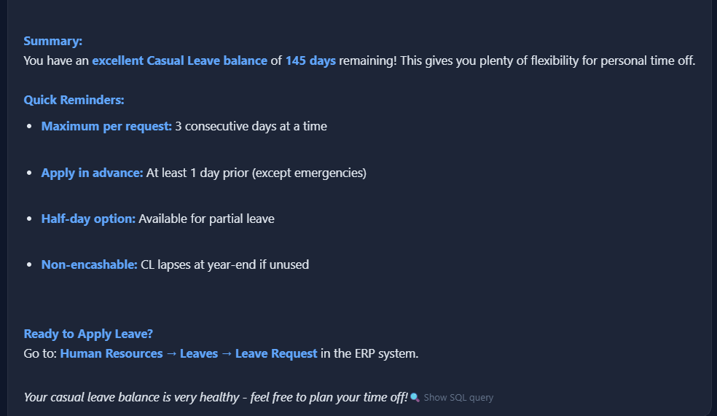
The responses should be concise and clear. It should just respond with a one liner saying
‘Your current CL balance is _____.”
Avoid making statements like – this gives you plenty of flexibility for personal time off.

4. We tried a prompt for “Show my recent payroll details” – would like to know from where the details are being picked up for the response.

5. While prompting HR agent with “Provide onsite bonus eligibility”, the agent responds with the following data.
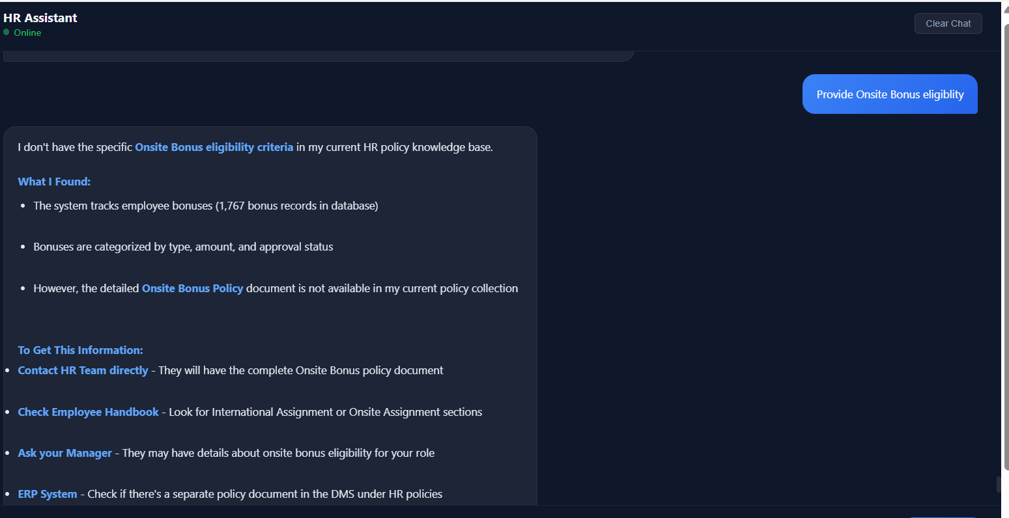
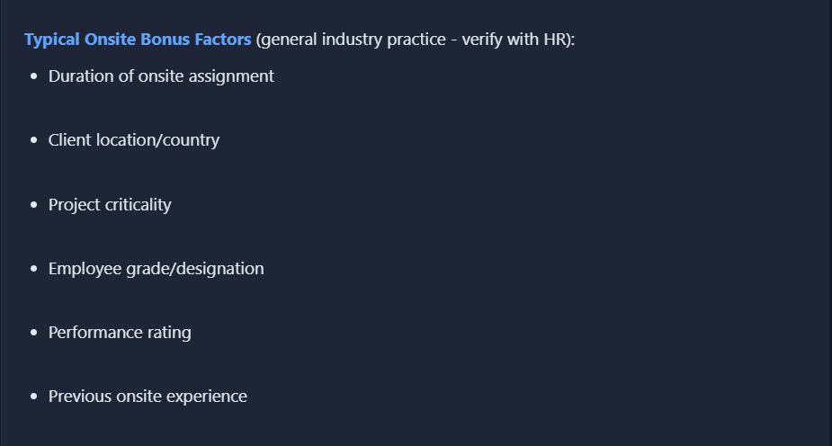
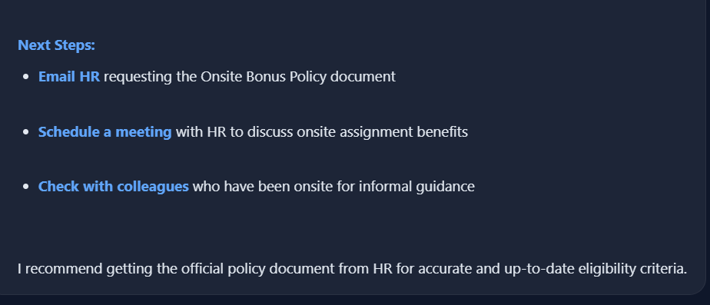
We understand that the HR policy is not available in the test DB, but the response to this should limit only to the actual eligibility criteria mentioned in the policy.
Refrain from sharing any additional data just because the policy details are not available.

6. We need some test credentials as employee logins so that we can try prompts and test the responses as an employee without any admin access.

7. Share the current test data that has gone into the preparation of this agent. This allows us to test and validate the responses accurately.

8. Once the prompt is given to the agent, the agent processes the prompt and generates response and it is pushed to the screen above the text box field (prompt box).
Suggesting that the text box field (prompt box) be displayed at the top of the page and responses to be displayed below the text box to allow user friendly scrolling.

9. Look and feel of the HR agent can be enhanced and made more attractive.

10. When logged in to the HR agent, it shows the following:
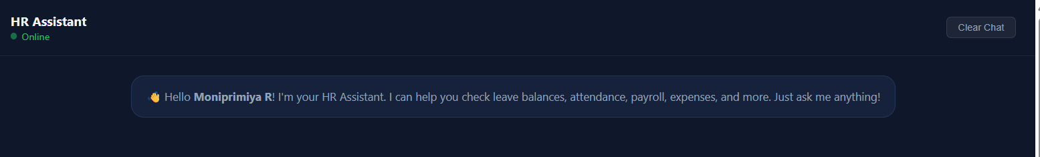
Instead we propose –
Hello Employee Name! I’m your HR Assistant. Ask me anything!
11. For further testing, we require all the Policies and Documents that are available on DMS in the current Odoo to be uploaded in the test environment. This will allow us to widen our test criteria.

